**MATLAB Package Installation Instructions:**

The MATLAB add-on **Data Acquisition Support Package for National Instruments NI-DAQmx Devices** is required.

1. Open MATLAB and go to Home -> Add-Ons
2. Search for “NI myDAQ…” and select “Data Acquisition Support Package for National Instruments NI-DAQmx Devices” and click Install

* “Data Acquisition Toolbox” should be automatically installed as well if it was not previously installed.

1. Close MATLAB and restart the computer. If the device is still not recognized, try un-plugging and re-plugging in the USB cable.

**NI myDAQ Information:**

Plug in the myDAQ with USB cable into one of the USB ports on the laptop

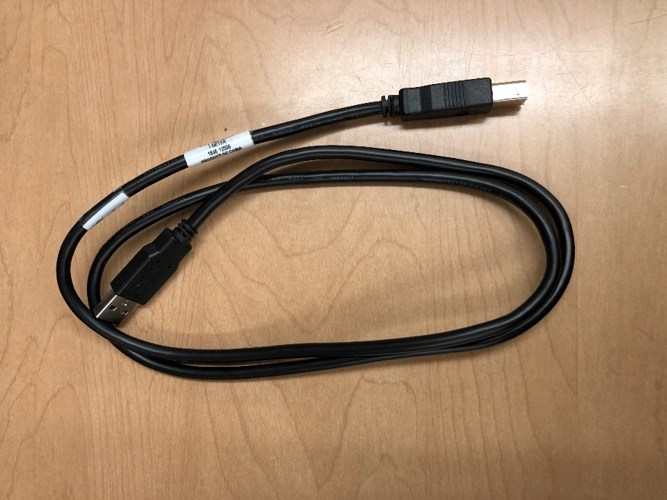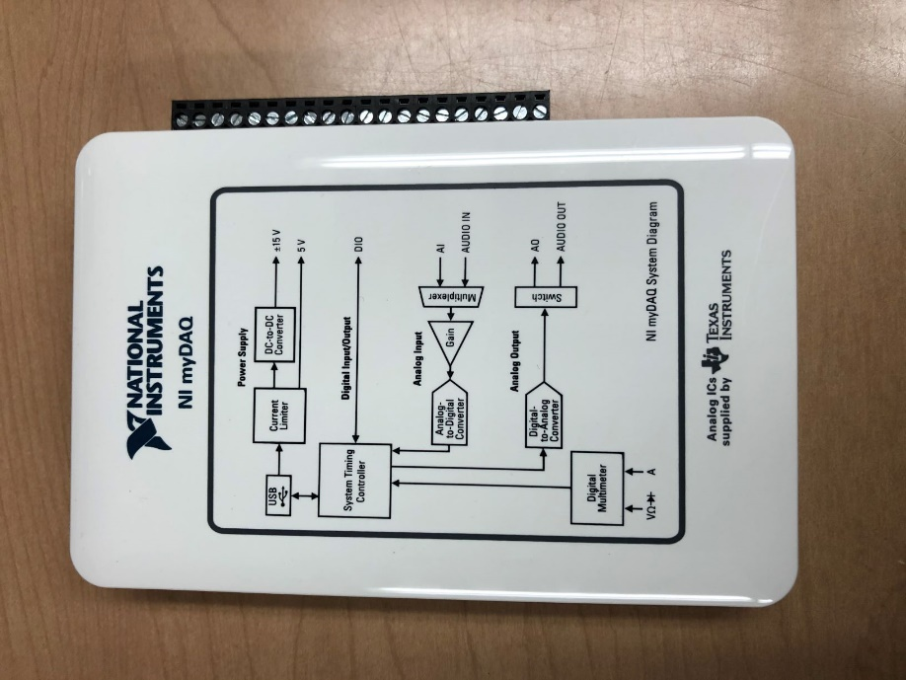

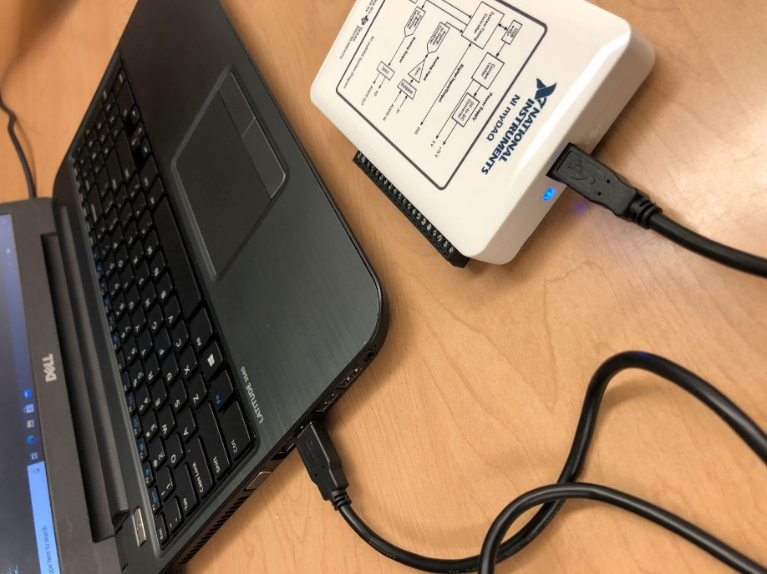

You should see blue light in the myDAQ near the USB connector port on the white myDAQ block

This action of connecting the USB cable into the computer from the myDAQ should auto start the application, NI Device Monitor.

It may detect myDAQ1 or myDAQ2, depends on the unit you are using.

Be sure to keep up with this subtlety (of myDAQ1 or myDAQ 2 ) as you may need to adjust for this in the MATLAB example.

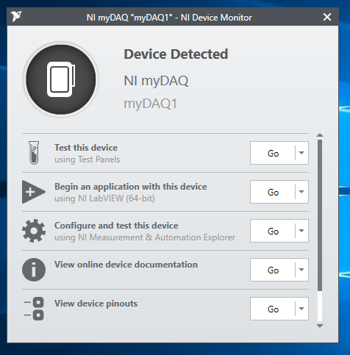

Now open up MATLAB

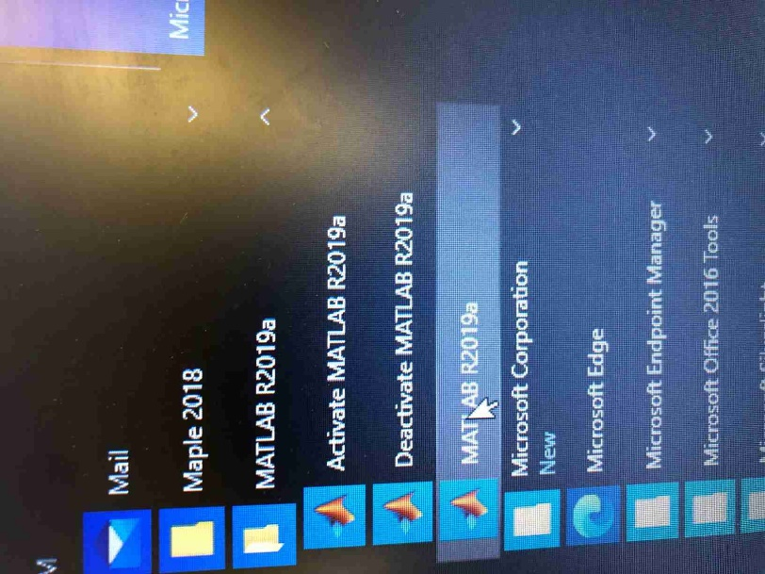

The other equipment you will need

Now you will need to make sure you have a signal to test, and some wires to get the signal into the myDAQ block. I tend to have another computer open to look for help online or to watch related videos. I use the oscilloscope to make sure I can measure my input with a second instrument just in case my data acquisition code is not doing something I expect. I use the function generator to produce sine wave voltages. Here is a photo of the setup I had going in lab.

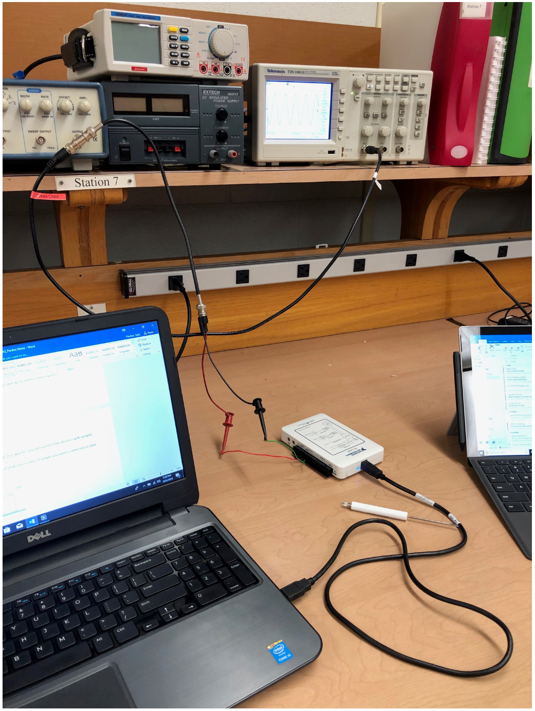

Wiring into the myDAQ

There is a screw terminal on the side of the myDAQ block. Please use the small screwdriver with NI lettering to try turning the screws to see how the terminal block works.

The input on the analog channel 0 needs to be setup as “differential” which means you need to the input signal’s (output from the function generator) “positive” lead to the positive 0+ and negative lead to the 0- and then ALSO run a connector wire from 0- to AIGRND. See image below.

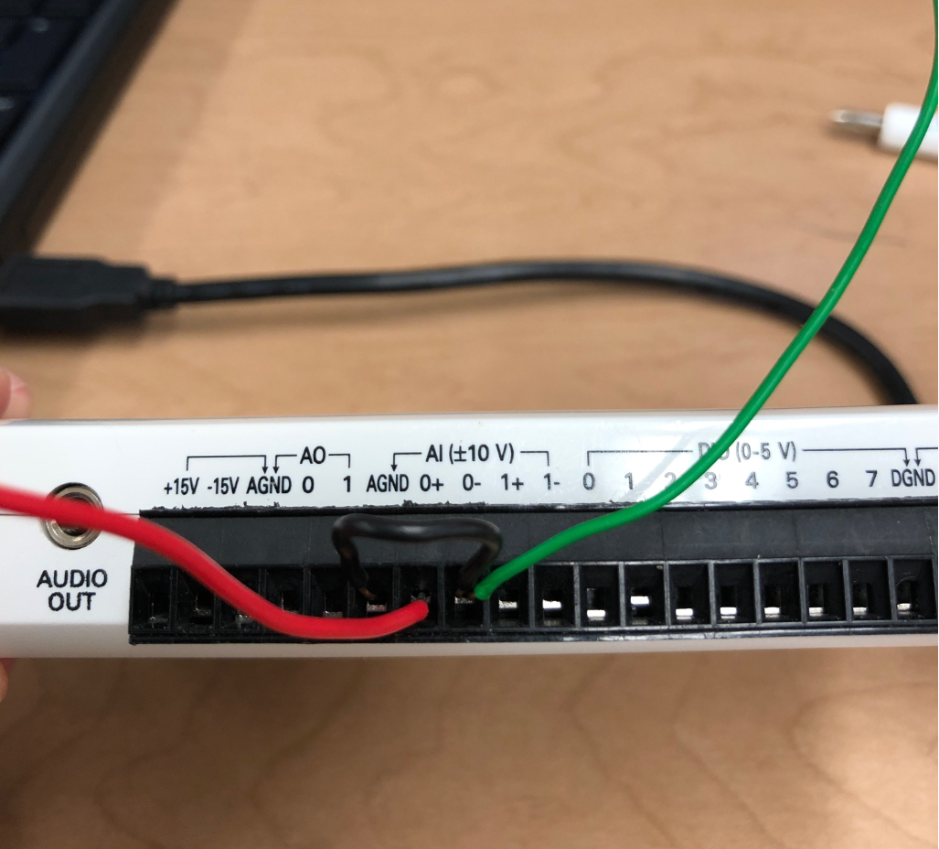

Now you can follow the steps of the MATLAB training to Get Started.

**Temperature Sensors TMP36 Information:**

